*I imagine this as a Barnes and Noble partnership/sponsorship with Buzzfeed – targeted at young adults, this would appear on Facebook newsfeeds, in Buzzfeed snap stories, etc.*

**5 Books You Need to Read Before You Turn 30**

See the world a little better. Understand yourself a little better. These books are modern masterpieces that anyone can learn from. Check them out at your local Barnes and Noble’s “Must-reads” section today.



***1. Eleanor Oliphant is Completely Fine –* Gail Honeyman**

What starts out as a humorous profile of a strange and quirky woman who has no regard for social cues and usually avoids people altogether becomes a heartfelt inspection of the ways a thoroughly scarred heart can start to mend and open once again. Eleanor will have you cackling with laughter one minute and tearing up the next. She is a force all her own and her journey will change the way you see those around you.

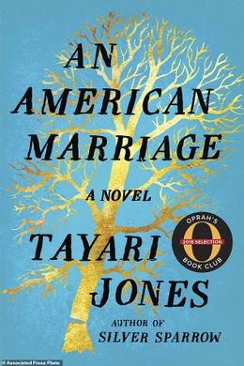

**2. *An American Marriage –* Tayari Jones**

This heartbreaking novel takes a hard look at relationships, race, and what it means to be married in 21st century America. When Celestial’s husband, Roy, is wrongly imprisoned shortly after their wedding, she has many hard decisions to make about when is the right time to move on, how to do it and what she is willing to leave behind. Roy, in turn, must come to terms with the fact that he won’t be able to pick up where he left off once he leaves prison.

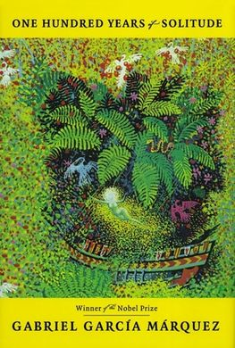

**3. *One Hundred Years of Solitude –* Gabriel Garcia Marquez**

Spanning the course of a century, Gabriel Garcia Marquez paints a picture of the rise and fall of a family that is at times romantic, and at others bleak and hopeless. The undercurrents of magic, tradition, and loneliness pervade each generation and leave their mark on each of the characters. A rare project in scope and in effect, this novel is an important read for anyone.

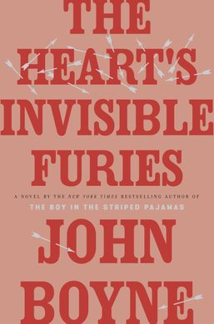

**4. *The Heart’s Invisible Furies –* John Boyne**

Boyne is known for creating unforgettable characters and evoking intense emotions from his readers. His latest novel is no different. Set in Ireland in the early 20th century, this book tackles issues of self-discovery, love, and acceptance in a time and place much less forgiving than our own. Though a longer read, you won’t be able to put it down as the narrative carries you seamlessly across time and space as you take an emotional journey that will stay with you long after you’ve closed the book.

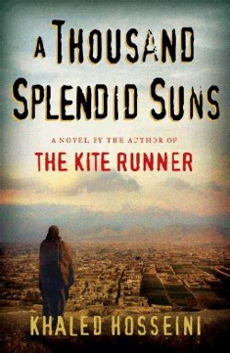

**5. *A Thousand Splendid Suns –* Khaled Hosseini**

In a stunning display of the tenacity of the human spirit and the strength that can come from companionship in hard times, this novel brings to life the struggles and atrocities of three decades of conflict in Afghanistan. At the same time heartbreaking and inspiring, the journey two women take through marriage, persecution, abuse, and self-deliverance is perspective-shifting and altogether unforgettable.